**Information and Instructions for Using the Student’s Academic Information System**

目录

Log in 2

Modules 2

1 : Academic Training 3

1.1 Basic information 4

1.2 Courses 6

1.3 Thesis 6

1.3.1 Academic Training Plan 6

1.3.2 Thesis Proposal 9

1.3.3 Mid-term Evaluation 13

1.3.4 Application for Thesis defense 17

1.4 Scientific Achievements 21

1.4.1 Publications 21

1.4.2 Patent 22

1.4.3 Books 22

1.4.4 Scientific Awards and Honors 22

1.4.5 Other 22

1.5 Scientific Reports and Social Activities 22

1.5.1 Scientific Reports 22

1.5.2 Social Activity 24

2. Degree System 25

2.1 Basic Information 25

# Log in

<http://sep.ucas.ac.cn/>

use name: email address

password: passport number

# Modules

After log in, you will see such an interface as shown below.

Basically, each icon represents a single module wither certain information regarding students. The module that you need to fill out is Academic Training (培养指导), which has been circled in red.

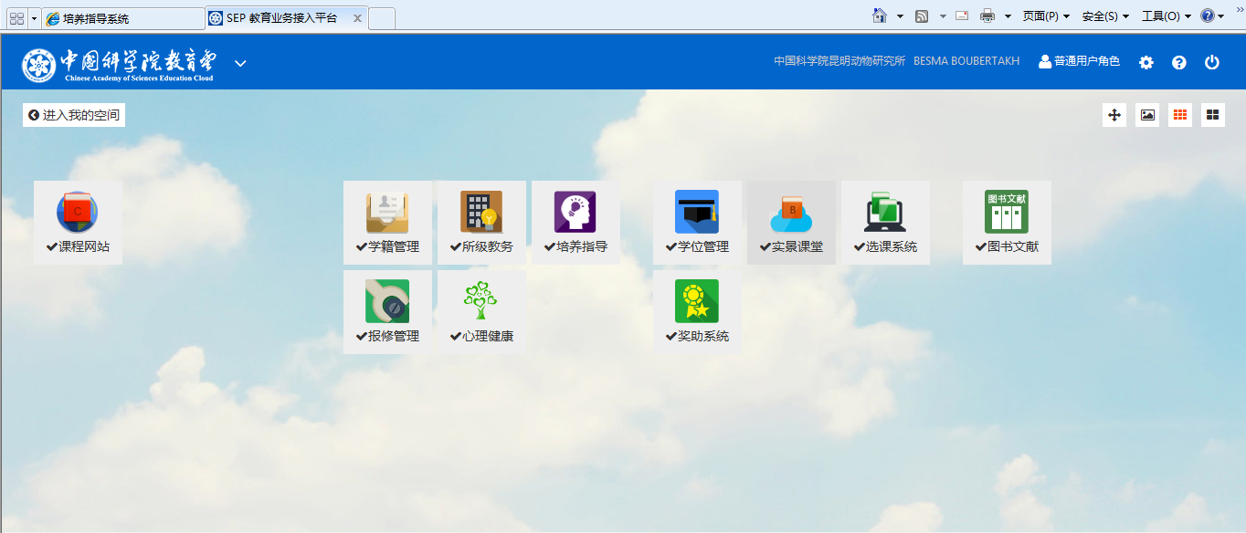

## 1 : Academic Training

After clicking on 培养指导(academic training), you will see such an interface as follows:

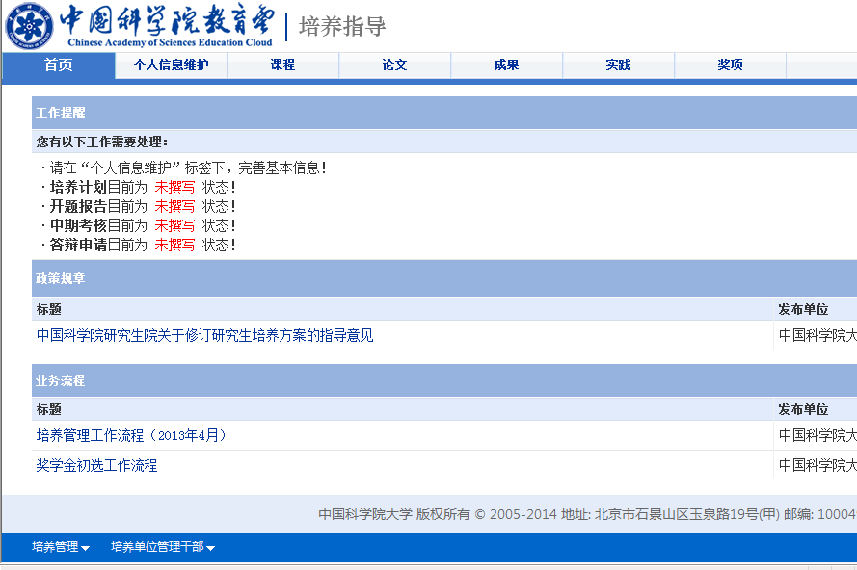

Awards and Honors

Social Activities

Achievements

Thesis

Courses

Basic personal info

Homepage

### 1.1 Basic information

First of all, please complete your basic information. Failure to do that will lead to the difficulty of going through the following steps.

After clicking on 个人信息维护(basic personal information), you can see the page as shown below:

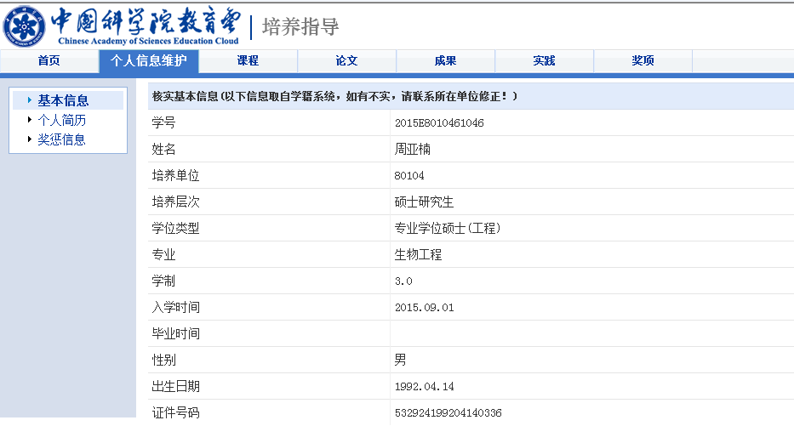

Information in the text box is retrieved from another system automatically, so you cannot change it. But please let me know if any information is incorrect.

**Basic Information**

**Passport Number**

**Birth Date**

**Gender**

**Graduation Date**

**Enrollment Date**

**Duration of Study**

**Major**

**Type of Degree**

**Level of Degree**

**Institute**

**Name**

**Student ID**

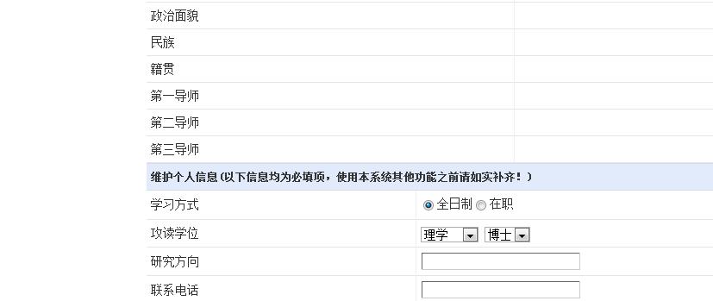

**Cell Phone Number**

**Contact phone number**

**Research Focus**

**Degree**

Part-time

Full time

**Political Status**

**Type of Study**

**Tertiary Supervisor**

**Secondary Supervisor**

**Primary Supervisor**

**Birthplace**

**Ethnic Group**

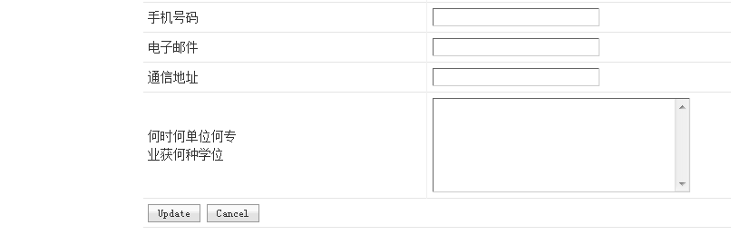

**Education Background**

**(time, place, major, and degree)**

**Address**

**Email**

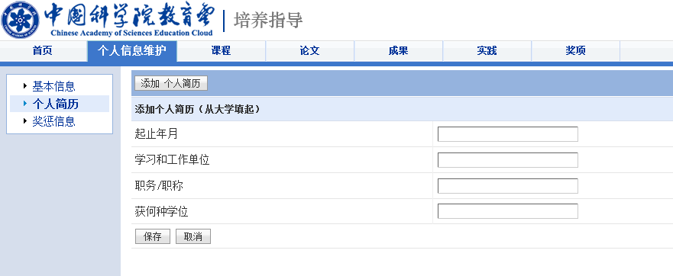

**Degree Obtained**

**Position**

**Organization**

**Period ( From Y-M to Y-M)**

**Add Experience**

**Experience**

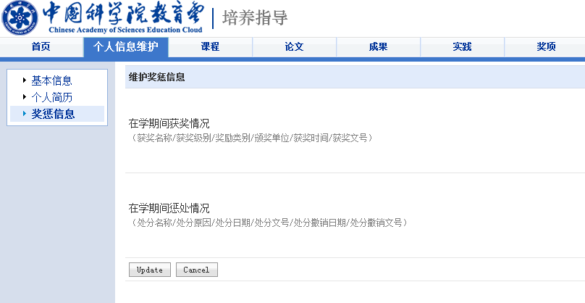

**Punishment during study at KIZ**

**Award and Honor during study at KIZ**

**Honor and Punishment**

### 1.2 Courses

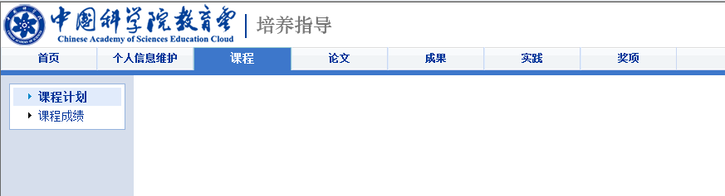

So far you do not need to work on this part.

### 1.3 Thesis

After you click on 论文(thesis), you will be transferred to such interface as below.

#### 3.1 Academic Training Plan

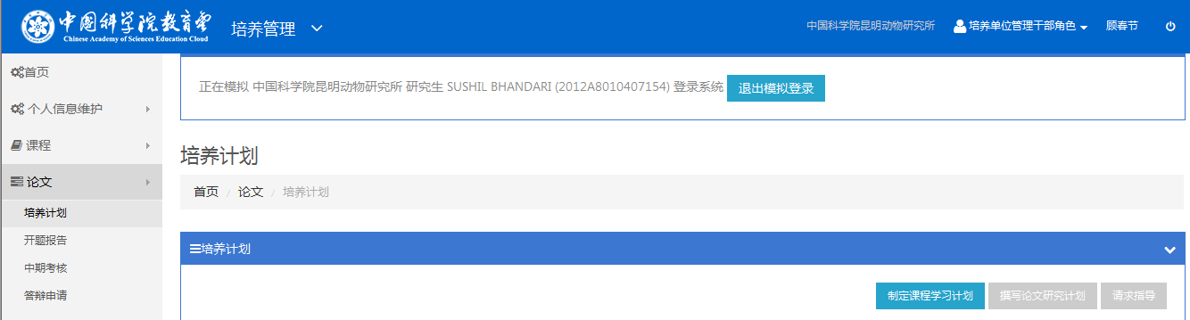

**Compose your thesis-writing plan**

**Academic Training Plan**

Please click on Course-taking plan.

**Course-taking plan**



Add Courses

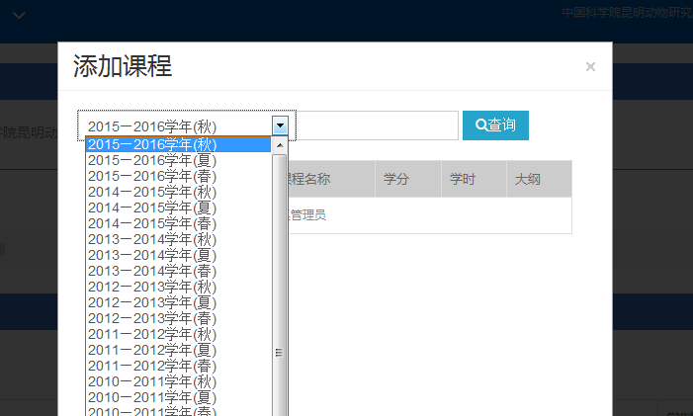

Please do ask your lab mate to help you with this one. Mainly it is to select those courses you planed to take as you started your study at KIZ.



Backward

**Compose your thesis-writing plan**

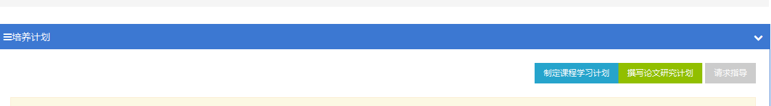

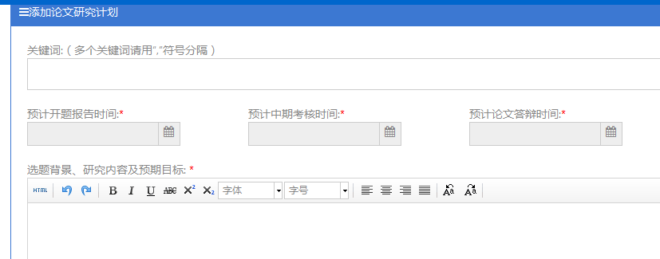

Why did you choose the research topic

What will you study

And what findings do you think you can get

Planned date for thesis defense.

Planned date for mid-term evaluation.

Planned date for thesis proposal defense

Key words of your thesis. Please use ; to separate them.



References

Save

Upload

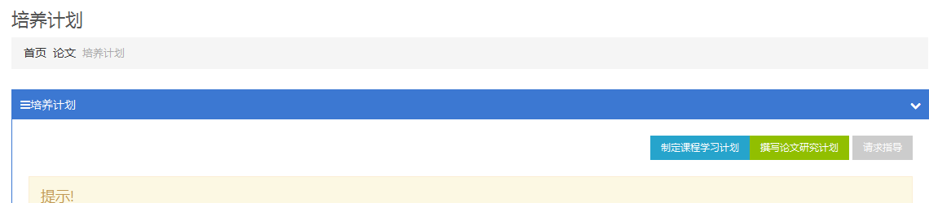

After you finish writing everything, please do not forget to seek for your supervisor’s guidance.

#### Thesis Proposal

***Step 1: Fill out the section of thesis proposal in this system***

After your write the report, please click on “请求指导” to send the report to your supervisor for guidance. Usually, Supervisor approves your report, and then the report will be transferred to the Office of student Affairs.

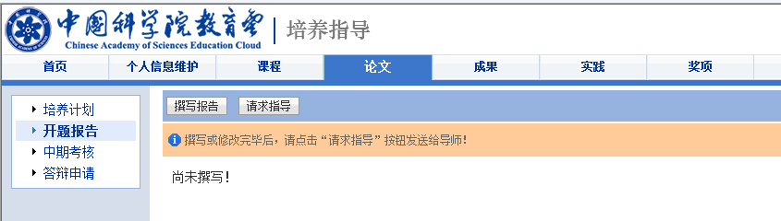

Thesis Proposal

**Ask for Supervisor’s Guidance**

**Write your report for thesis proposal**

*Click on 撰写报告(write your report for thesis proposal) first.*

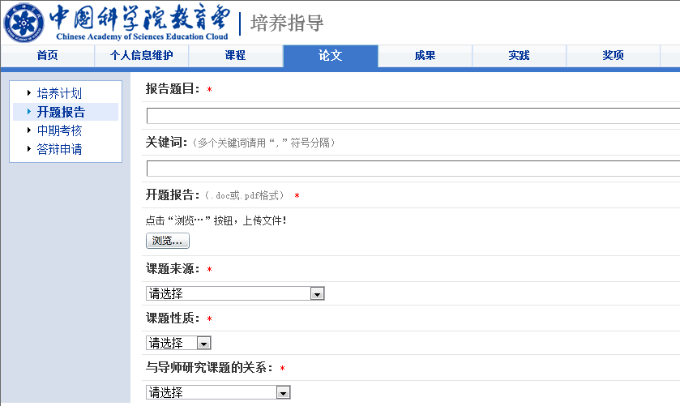

**Whether this is a part of the research project your supervisor is working on(Please find the options below)**

**Type of Research Project (Please find the options below)**

**Please choose among the options. (pls ask labamtes for help)**

**Source of the research project**

**Upload your report (.doc or .pdf)**

**Browse to retrieve the document**

**Key words**

**Title of your report of the thesis proposal**

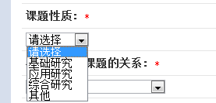

**Other**

**Comprehensive Research**

**Applied Research**

**Basic Research**

**Type of Research Project**

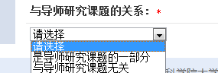

**Whether this is a part of the research project your supervisor is working on**

**No**

**Yes**

Continued:

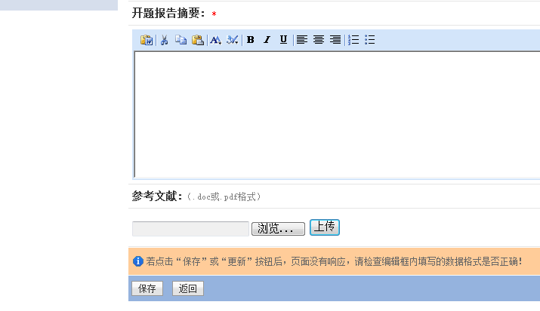

**Save Go back**

**Browse Upload**

**References (.doc &.pdf)**

**The abstract of your report of the thesis proposal**

***Step 2: Send your report to Supervisor***

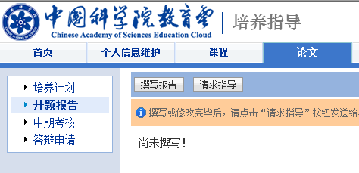

**Please click here**

***Step3 Download the Registration Form of Thesis Proposal***

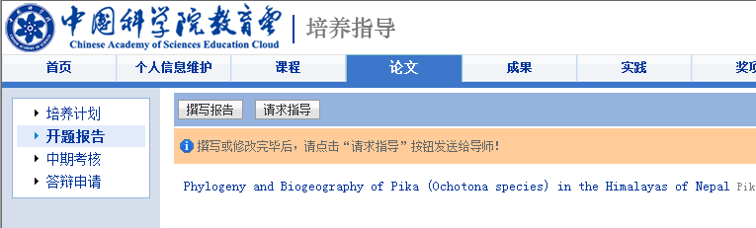

After you finish the first step, you will see your report is shown here.

To download the registration form, please click on the report, and then you will see such an interface as below:

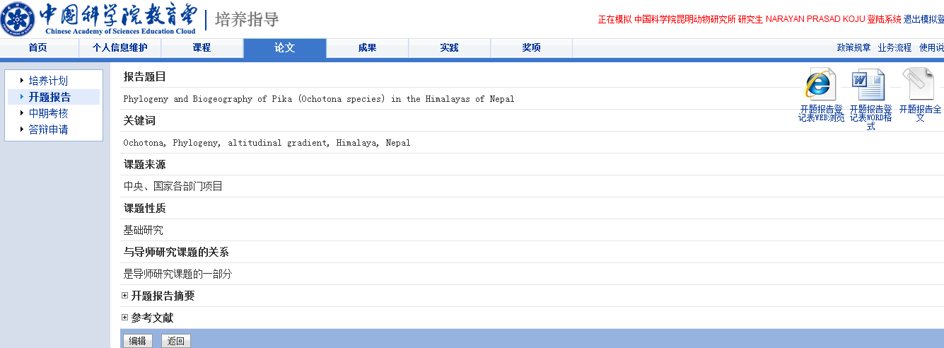

Go back

Click here if you want to edit your information again.

Click here to download the Registration Form

Please note:

The Registration Form you download from the system can have some format errors. Please always check the format against the Registration From I sent you before you print it out.

#### Mid-term Evaluation

***Step 1: Fill out the section of mid-term evaluation in the system***

After your write the application, please click on “请求指导” to send the report to your supervisor for guidance. Usually, Supervisor approves your application, and then the application will be transferred to the Office of student Affairs.

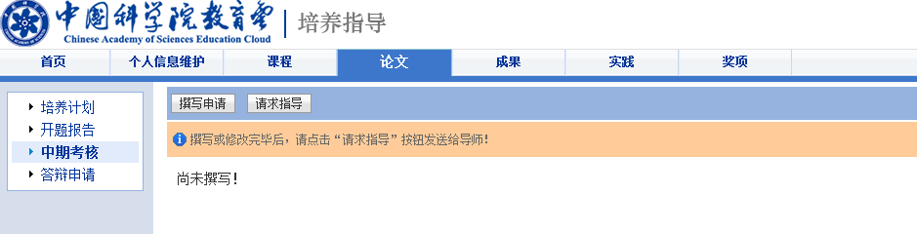

Write your Mid-term report

Click here first

Mid-term Evaluation

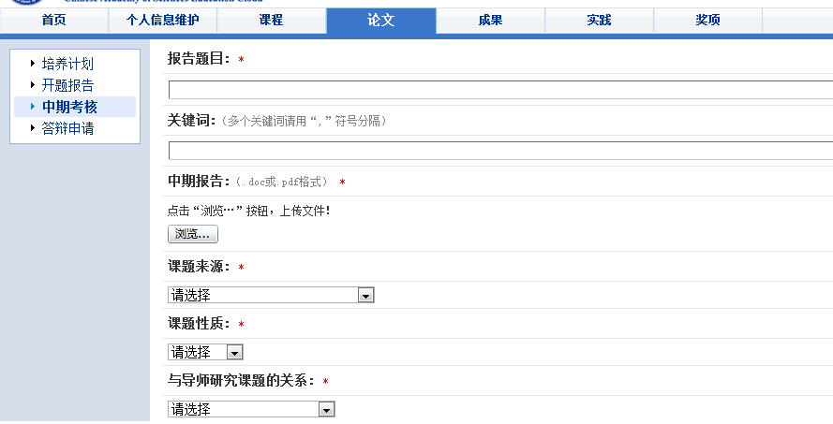

Content on this page is totally the same with the page of Thesis Proposal. You can just refer to Page 7 of this document to find the translations.

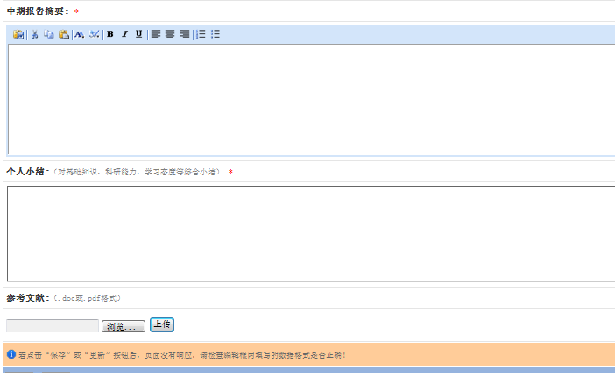

Go back

Save

Upload your reference

Summary

About how you master the basic knowledge, your research ability, and your study/work attitude

Abstract of your mid-term report.

Type in this box, please.

***Step 2: Send your report to Supervisor***

After saving the report, please click on the button of asking for supervisor’s guidance.

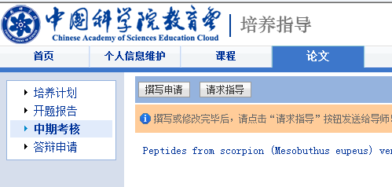

***Step3 Download the Registration Form of Thesis Proposal***

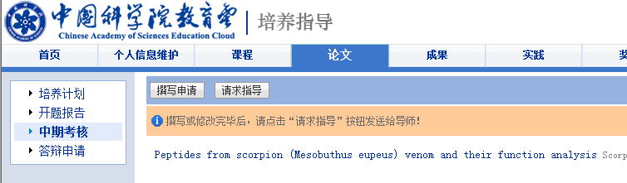To download the registration form, please click on the report, and then you will see such an interface as below.

After you finish the first step, you will see your report is shown here.

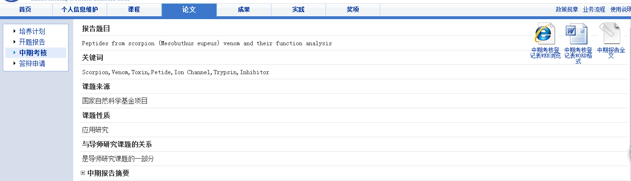 

Edit

Click here to download the registration Form

Please note:

The Registration Form you download from the system can have some format errors. Please always check the format against the Registration From I sent you before you print it out.

#### 1.3.4 Application for Thesis defense

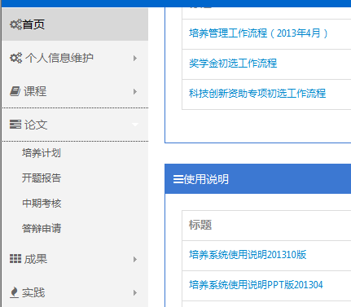

Then click here; it means application for thesis defense.

Click here first; it means thesis.

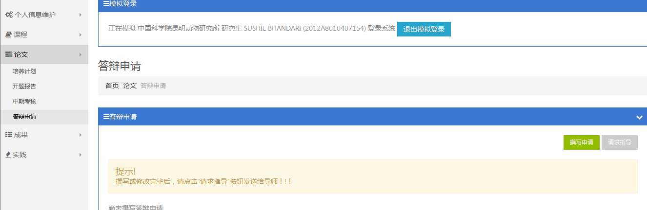

Click here to start writing your thesis defense application

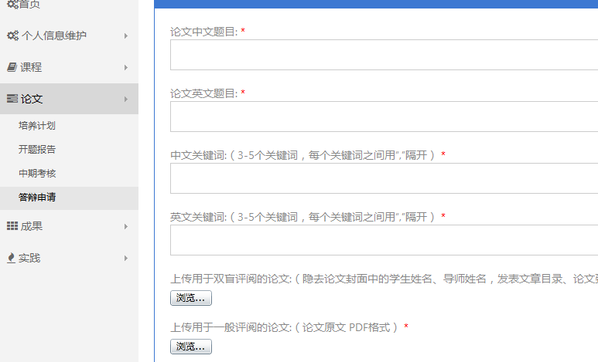

Upload the complete version of your thesis.

Upload the version of your thesis for double-blind examination. It should not contain your name, your supervisor’s name, publications and acknowledgements.

Three to five key words in English and please use , to separate words.

Three to five key words in Chinese and please use , to separate words.

Thesis Title in English

Thesis Title in Chinese

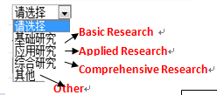 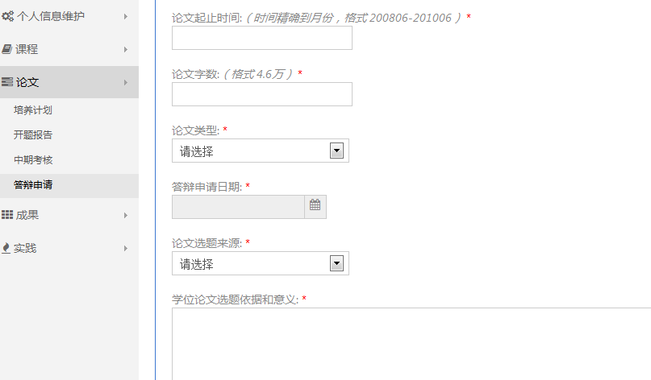

Reasons why you chose the research topic.

And Implications/significance of your research.

Sources of funding. Please ask your lab mate/supervisor for help with this one.

Planned date for thesis defense.

Thesis Type.

Duration of Thesis Work.

From YYYYMMDD to YYYYMMDD

Length of thesis.

XX words.

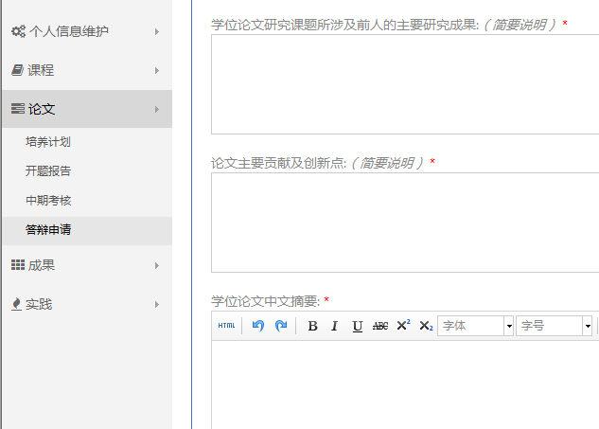

Abstract in Chinese.

Contribution and innovation of the thesis..

A brief summary of others’ findings on your research topic.

.

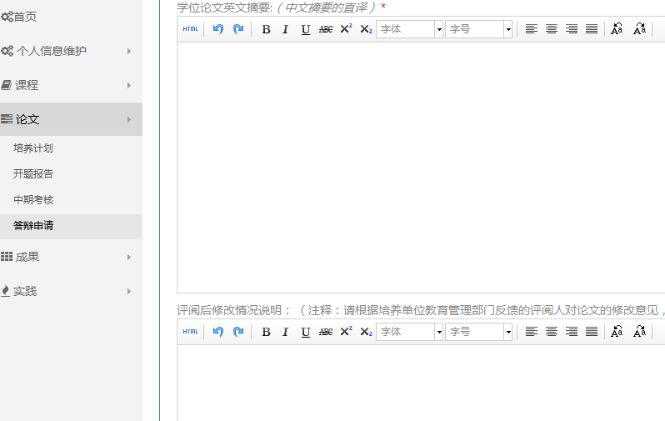

Thesis revision, if any, after thesis examination.

Abstract in English.

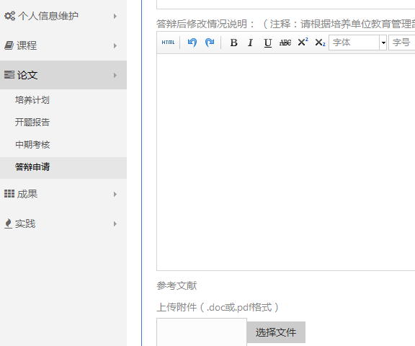

browse

References. .doc, or .pdf

Thesis revision, if any, after thesis defense.



Cancel

Save

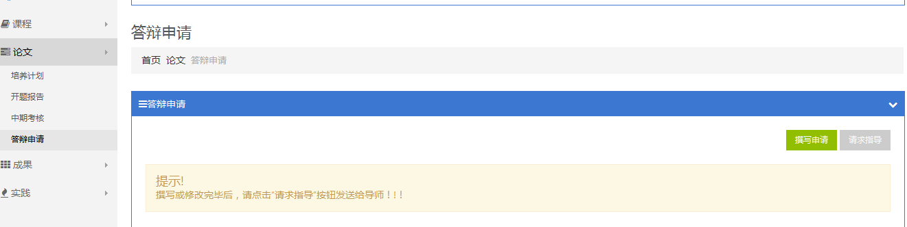

Ask for Supervisor’s Guidance

### 1.4 Scientific Achievements

#### 1.4.1 Publications

Add

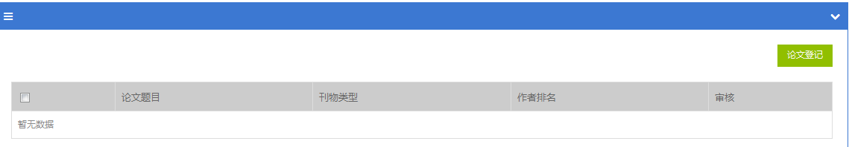

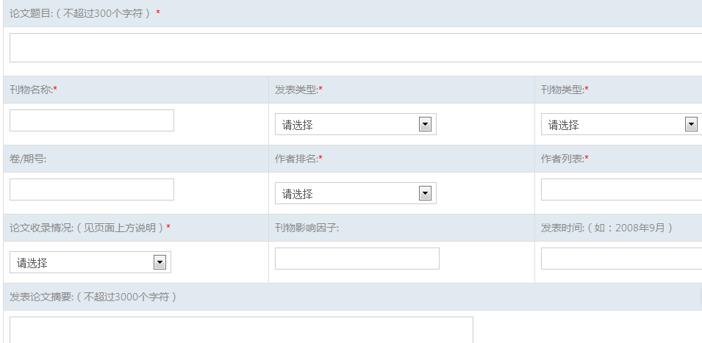

Abstract

Date Published

Impact Factor

Index

Authorship Order(In which place is your name?)

List of Authors

Volume/Issue No.

Type of Publication

Type of Journal

Jounal Name

Title of Your Paper

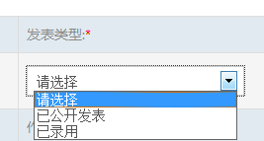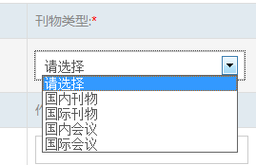

Domestic Journal

International Journal

Domestic Conference

International Conference

Published

Accepted

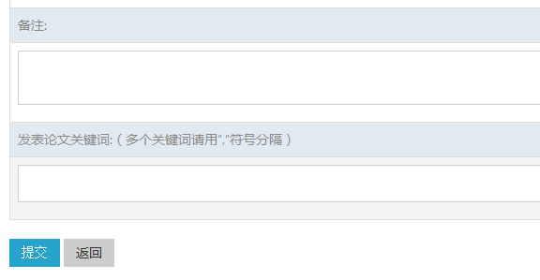

Submit

Key Words. Please separate the words with ,.

Notes

#### 1.4.2 Patent

#### 1.4.3 Books

#### 1.4.4 Scientific Awards and Honors

#### Other

### 1.5 Scientific Reports and Social Activities

Scientific Reports You gave

Seek for Supervisor’s Guidance

Seminars you attended

#### 1.5.1 Scientific Reports

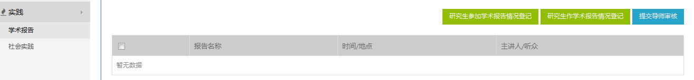

Social Activities

Social reports

First, Please click on Seminars you attended. (We need at least five)

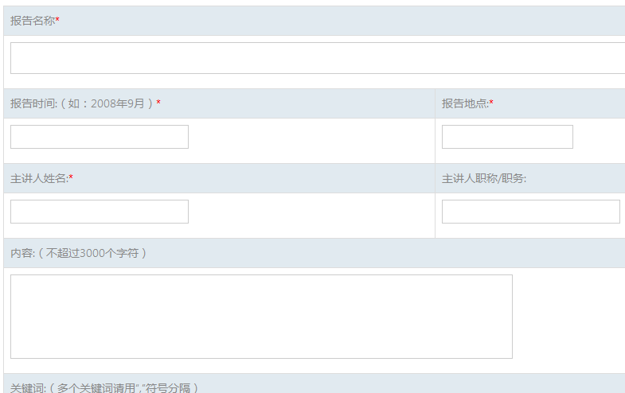

Content of the Seminar

Key words. Please use , to separate the words.

The Speaker’s position/job title.

Where the seminar was given.

The name of the sminar’s speaker.

Date of the Seminar

Title of the Seminar



Backword

Save

Please click on Scientific Reports You Gave. We need at least three.

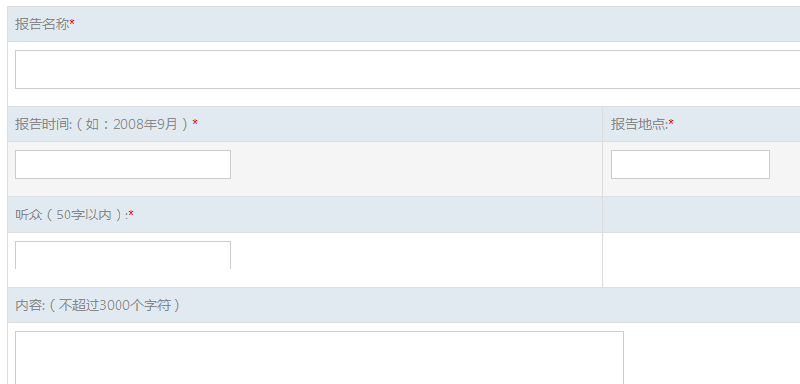

Content of the report

Where did you give the presentation/report

Audience

Date

Title of Your Report



Key words. Please use , to separate the words.



Backword

Save

#### 1.5.2 Social Activity

Add

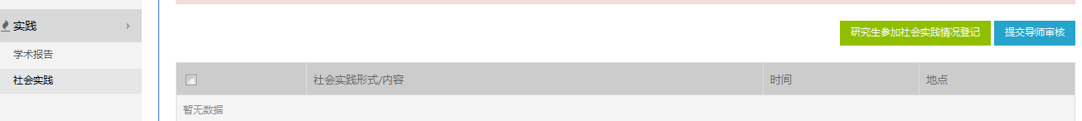

Social Activity

Please click on Social Activity first and then click on Add. We need at least one.

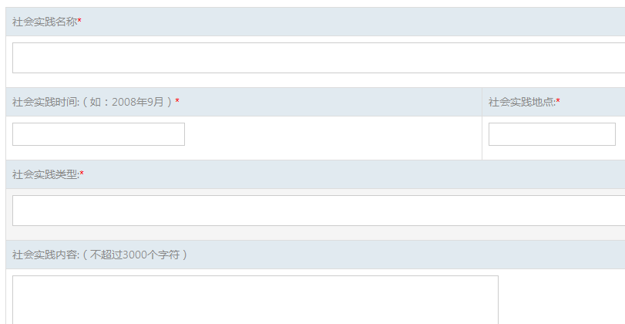

Content of Your Social Activity

Type of Your Social Activity

When

Where

The Name of Your Social Activity

Please do not forget to ask for your supervisor’s guidance.

## 2. Degree System

### 2.1 Basic Information